D1_Nihar_84066
ASSIGNMENT 8
1. D1_nihar_84066>select onum, snum, amt*0.12"commisssion" from ORDERS;
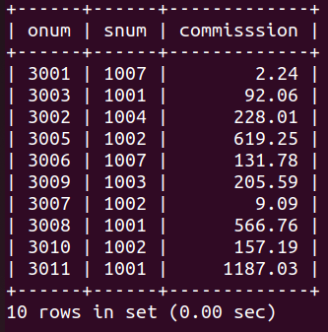

2. D1_nihar_84066>select concat('For the city ',city,' the highest rating is:',max(rating)) AS output from CUSTOMERS group by city;
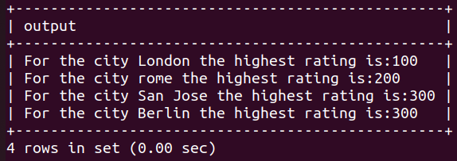

3. D1_nihar_84066>select rating, cname, cnum from CUSTOMERS order by rating desc;

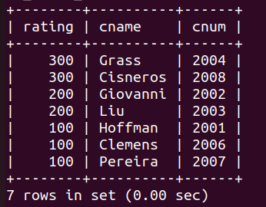

4. D1_nihar_84066>select odate, sum(amt)"total order" from ORDERS group by odate order by sum(amt) desc;
